**Hello Team!** **Consider the below two tables**:

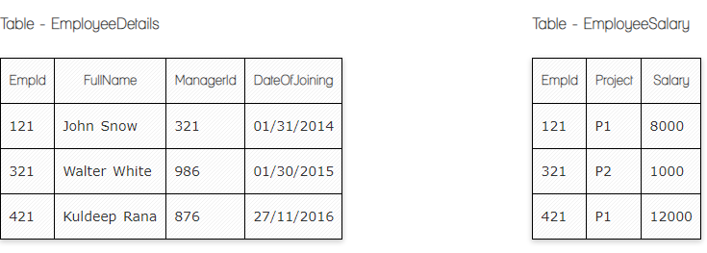

**Ques.1. Write a SQL query to fetch the count of employees working in project 'P1'.**

**Your Answer:**

**SELECT COUNT (EmpID)**

**FROM EmployeeSalary**

**GROUP BY Project**

**HAVING Project = ‘P1’**

**Ques.2. Write a SQL query to fetch employee names having salary greater than or equal to 5000 and less than or equal 10000.**

**Your Answer:**

**SELECT EmployeeDetails.FullName**

**FROM EmployeeDetails**

**INNER JOIN EmployeeSalary**

**ON EmployeeDetails.EmpId=EmployeeSalary.EmpID**

**WHERE EmployeeSalary<=’5000’ and <= ‘10000’**

**Ques.3. Write a SQL query to fetch count of employees sorted by project's count in descending order.**

**Your Answer:**

**SELECT COUNT(EmpId)**

**FROM EmployeeSalary**

**ORDER BY Project DESC**

**Ques.4. Write a query to fetch employee names and salary records. Return employee details even if the salary record is not present for the employee.**

**Your Answer:**

**SELECT EmployeeDetails.FullName, EmployeeSalary.Salary**

**FROM EmployeeDetails**

**LEFT JOIN EmployeeSalary**

**ON EmployeeDetails.EmpId=EmployeeSalary.EmpID**

**Ques.5. Write a SQL query to create an empty table with ‘Test’ name.**

**Your Answer:**

**CREATE TABLE ‘Test’**

**Ques.6. Write a SQL query to delete an empty table with ‘Test’ name.**

**Your Answer:**

**DROP TABLE ‘Test’**

**Ques.7. Write a SQL query to fetch all the Employees details from EmployeeDetails table who joined in Year 2016.**

**Your Answer:**

**SELECT \***

**FROM EmployeeDetails**

**WHERE DateOfJoining like '%2016'**

**Ques.8. Write a SQL query to insert new record to the EmployeeDetails table with any data.**

**Your Answer:**

**INSERT INTO EmployeeDetails (FullName, ManagerID, DateOfJoining)**

**VALUES (‘Agahvni Har’, ‘555’, ’01.05.2023’ )**

**Ques.9. Write a SQL query to update EmployeeSalery table with setting Salary to 2000 for Project P2.**

**Your Answer:**

**UPDATE EmployeeSalery**

**SET Salary = 2000**

**WHERE Project = 'P2'**

**Ques.10. Write a SQL query to right join both tables and draw the results.**

**Your Answer:**

**SELECT \***

**FROM EmployeeDetails**

**RIGHT JOIN EmployeeSalery ON EmployeeDetails.EmpId = EmployeeSalery.EmpId**

**Now take these two tables:**

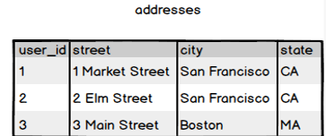

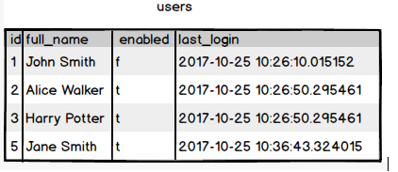

**Ques.11. Write a SQL query to fetch all users full_name from San Francisco.**

**Your Answer:**

**SELECT users.full_name**

**FROM users**

**RUGHT JOIN adresses ON users.id = adresses.user_id**

**WHERE city = 'San Francisco'**

**Ques.12. Write a SQL query to fetch all users full_name, last_login who are enabled**

**Your Answer:**

**SELECT users.full_name, last_login**

**FROM users**

**WHERE enabled = 't'**

**Ques.13. Write a SQL query to fetch all users full_name who are not from Main street**

**Your Answer:**

**SELECT users.full_name**

**FROM users**

**INNER JOIN adresses ON users.id = adresses.user_id**

**WHERE not street= 'Main Street'**

**Ques.14. Write a SQL query to fetch all users full_name who are from Main street or San Francisco**

**Your Answer:**

**SELECT users.full_name**

**FROM users**

**INNER JOIN adresses ON users.id = adresses.user_id**

**WHERE street = 'Main Street' or city = 'San Francisco'**

**Ques.15. Write a SQL query to fetch user full_name who is equal to user_id from Boston (find user_id value in sub_query)**

**Your Answer:**

**SELECT users.full_name**

**FROM users**

**INNER JOIN adresses ON users.id = adresses.user_id**

**WHERE city = 'Boston'**

**SELECT full_name**

**FROM users**

**WHERE id=(SELECT user_id FROM addresses WHERE city=’Boston’)**